

**VIVEKANANDA INSTITUTE OF PROFESSIONAL STUDIES - TECHNICAL CAMPUS**

**Grade A++ Accredited Institution by NAAC**

NBA Accredited for MCA Programme; Recognized under Section 2(f) by UGC;

Affiliated to GGSIP University, Delhi; Recognized by Bar Council of India and AICTE

An ISO 9001:2015 Certified Institution

**SCHOOL OF ENGINEERING & TECHNOLOGY**

**B.Tech. Programme:** CSE - B

**Course Title:** Python Programming

**Course Code:** AI-302P

**Submitted To: Submitted By:** Ms. Aashita Chhabra  **Name:** Ishaan Jain

(Python Instructor) **Enrolment No:** 06117702722

**Class and Section:** CSE-B



**VIVEKANANDA INSTITUTE OF PROFESSIONAL STUDIES - TECHNICAL CAMPUS**

**Grade A++ Accredited Institution by NAAC**

NBA Accredited for MCA Programme; Recognized under Section 2(f) by UGC;

Affiliated to GGSIP University, Delhi; Recognized by Bar Council of India and AICTE

An ISO 9001:2015 Certified Institution

**VISION OF INSTITUTE**

To be an educational institute that empowers the field of engineering to build a sustainable future by providing quality education with innovative practices that supports people, planet and profit.

**MISSION OF INSTITUTE**

To groom the future engineers by providing value-based education and awakening students' curiosity, nurturing creativity and building  
capabilities to enable them to make significant contributions to the world.

**INDEX**

|  |  |  |  |  |  |  |  |  |
| --- | --- | --- | --- | --- | --- | --- | --- | --- |
| **S.no** | **EXPERIMENT** | **Date** | **Marks** | | | **Remark** | **Updated Marks** | **Faculty Signature** |
| **Laboratory Assessment** | **Class Participation** | **Viva** |
| **1** | Create a program that prompts the user for their name and age and prints a personalized message. |  |  |  |  |  |  |  |
| **2** | Program prompting the user for their age and tells if they can vote in the next election. |  |  |  |  |  |  |  |
| **3** | Calculate the factorial of a number entered by the user using a loop |  |  |  |  |  |  |  |
| **4** | Lists and arrays: Create a program that prompts the user for a list of numbers and then sorts them in ascending order. |  |  |  |  |  |  |  |
| **5** | prompt the user to input a string and then print out the reversed string, concatenate and length |  |  |  |  |  |  |  |
| **6** | Functions: Calculate the area of a circle based on the radius entered by the user. |  |  |  |  |  |  |  |
| **7** | Classes and objects: Create a program that defines a class to represent a car and then creates an object of that class with specific attributes. |  |  |  |  |  |  |  |
| **8** | File input/output: Create a program that reads data from a file and writes it to another file in a different format. |  |  |  |  |  |  |  |
| **9** | Regular expressions: Create a program that uses regular expressions to find all instances of a specific pattern in a text file. |  |  |  |  |  |  |  |
| **10** | # Exception handling: Create a program that prompts the user for two numbers and then divides them, handling any exceptions that may arise. |  |  |  |  |  |  |  |

**INDEX**

|  |  |  |  |  |  |  |  |  |
| --- | --- | --- | --- | --- | --- | --- | --- | --- |
| **S.no** | **EXPERIMENT** | **Date** | **Marks** | | | **Remark** | **Updated Marks** | **Faculty Signature** |
| **Laboratory Assessment** | **Class Participation** | **Viva** |
| **11** | GUI programming: Create a program that uses a graphical user interface (GUI) to allow the user to perform simple calculations. |  |  |  |  |  |  |  |
| **12** | Web scraping: Create a program that uses a web scraping library to extract data from a website and then stores it in a database. |  |  |  |  |  |  |  |
| **13** | Data visualization: Create a program that reads data from a file and then creates a visualization of that data using a data visualization library. |  |  |  |  |  |  |  |
| **14** | Machine learning: Create a program that uses a machine learning library to classify images based on their content. |  |  |  |  |  |  |  |
| **15** | Networking: Create a program that uses a networking library to communicate with a server and retrieve data from it. |  |  |  |  |  |  |  |

**Experiment 1**

**Aim:**

**Basic data types and operators: Create a program that prompts the user for their name and age and prints a personalized message.**

**Code:**

# Create a program that prompts the user for their name and age and prints a personalized message.

def get_user_info():

name = input("Please enter your name: ")

age = int(input("Please enter your age: "))

return name, age

def print_personalized_message(name, age):

"""Print a personalized message"""

if age < 18:

message = f"Hello {name}, you are still young and have a bright future ahead!"

elif age < 65:

message = f"Hello {name}, you are in the prime of your life!"

else:

message = f"Hello {name}, you have gained a lot of experience and wisdom over the years!"

print(message)

name, age = get_user_info()

print_personalized_message(name, age)

**Output:**

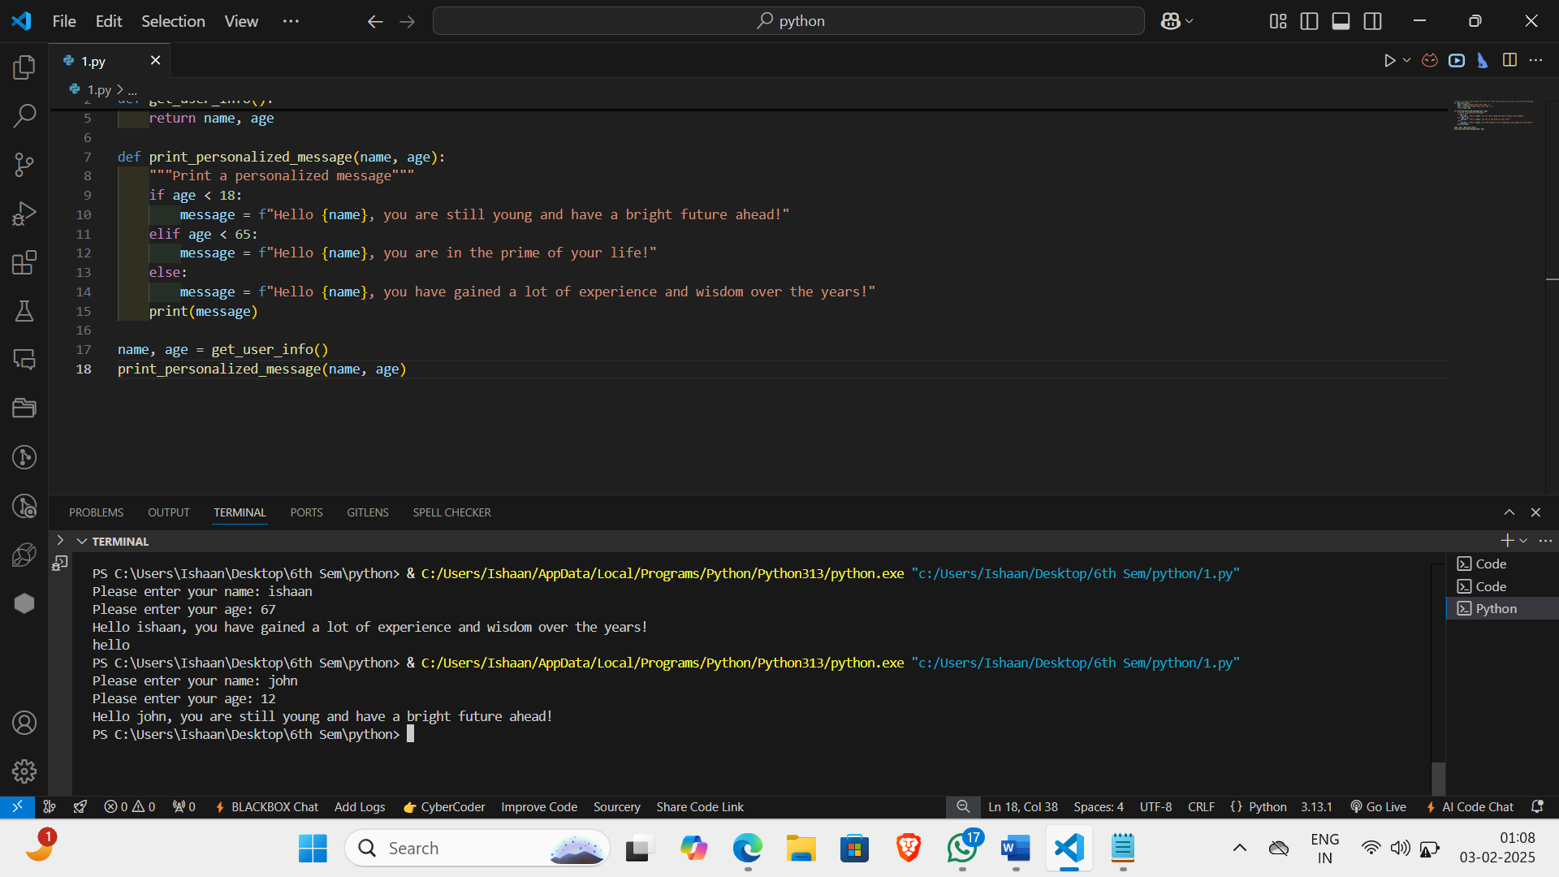

**Learning Outcomes:**

**Experiment 2**

**Aim:**

**Conditional statements: Create a program that prompts the user for their age and tells them if they can vote in the next election.**

**Code:**

#Program prompting the user for their age and tells if they can vote in the next election.

def get_user_age():

    """Get user's age"""

    while True:

        try:

            age = int(input("Please enter your age: "))

            return age

        except ValueError:

            print("Invalid input. Please enter a valid age.")

def check_voting_eligibility(age):

    """Check if the user is eligible to vote"""

    if age >= 18:

        print("You are eligible to vote in the next election.")

    else:

        print(f"You are not eligible to vote in the next election. You need to be at least 18 years old. You have {18 - age} years to go.")

age = get_user_age()

check_voting_eligibility(age)

**Output:**

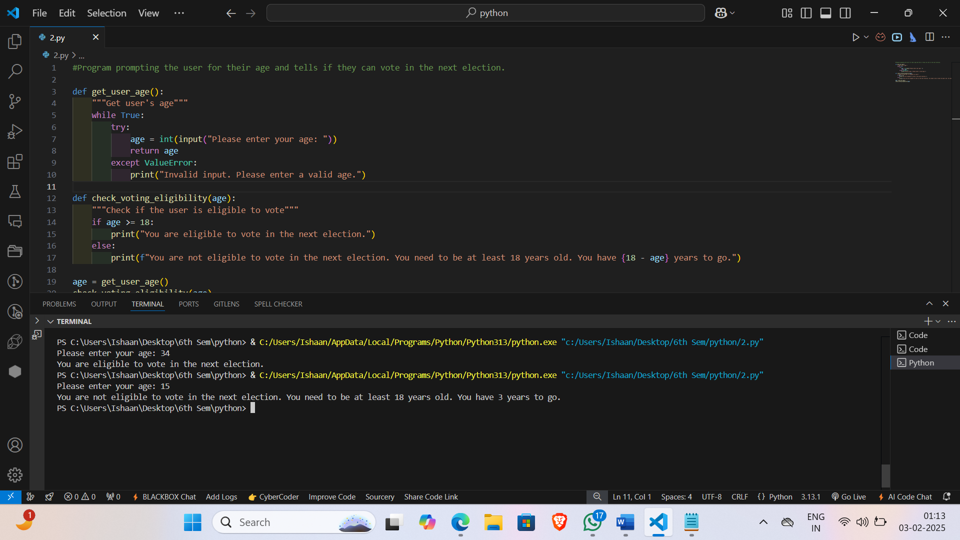

**Learning Outcomes:**

**Experiment 3**

**Loops: Create a program that calculates the factorial of a number entered by the user using a loop.**

**Code:**

# Calculate the factorial of a number entered by the user using a loop

def get_user_input():

    """Get user's input"""

    while True:

        try:

            num = int(input("Please enter a non-negative integer: "))

            if num < 0:

                print("Invalid input. Please enter a non-negative integer.")

            else:

                return num

        except ValueError:

            print("Invalid input. Please enter a valid integer.")

def calculate_factorial(num):

    """Calculate the factorial of a number using a loop"""

    factorial = 1

    for i in range(1, num + 1):

        factorial *= i

    return factorial

num = get_user_input()

factorial = calculate_factorial(num)

print(f"The factorial of {num} is {factorial}.")

**Output:**

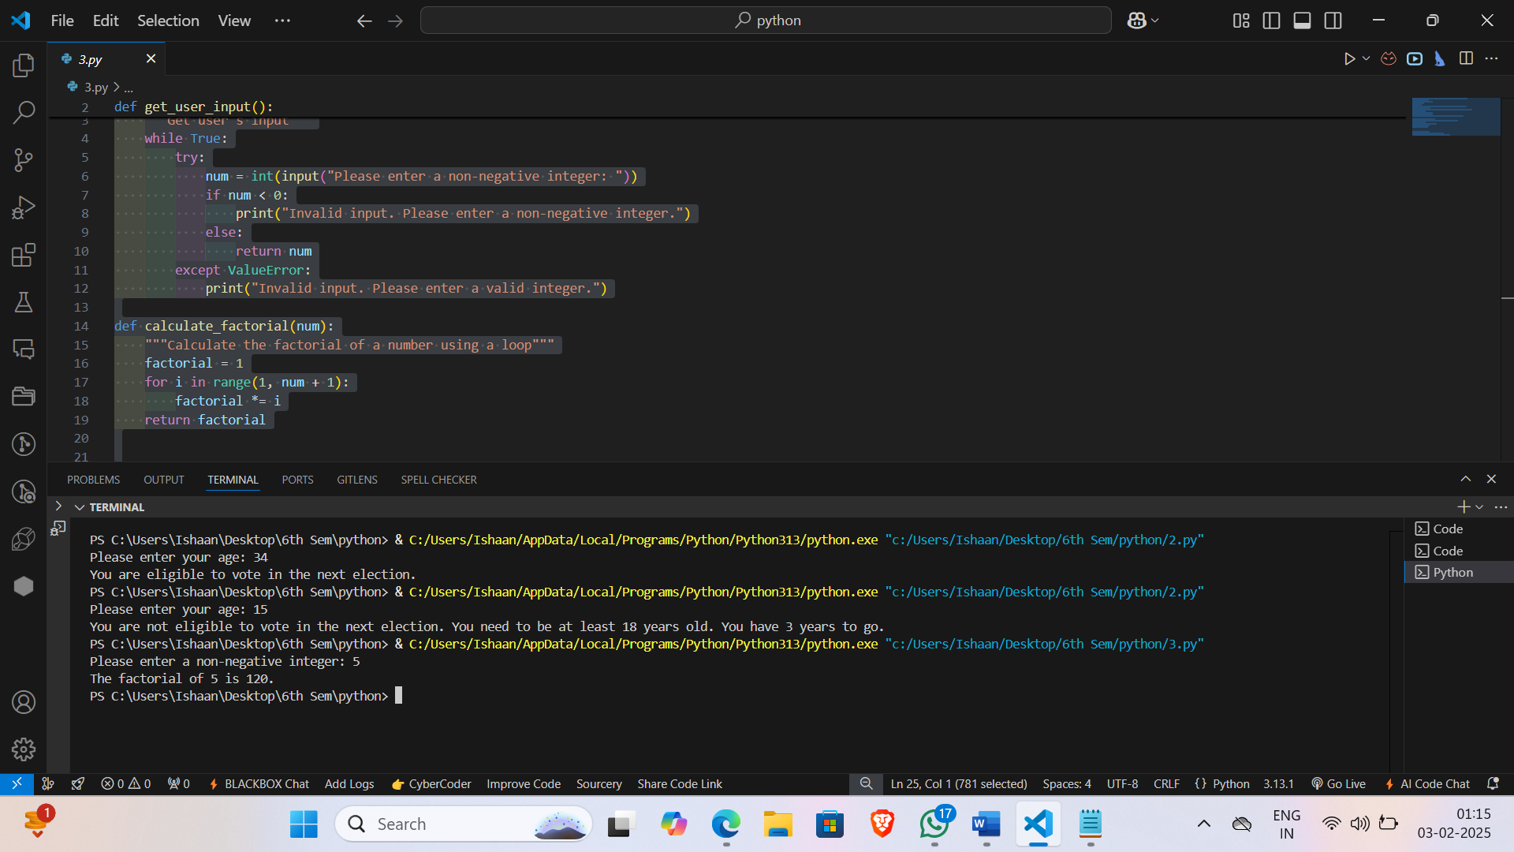

**Learning Outcomes:**

**Experiment 4**

**Aim:**

**Lists and arrays: Create a program that prompts the user for a list of numbers and then sorts them in ascending order.**

**Code:**

# Lists and arrays: Create a program that prompts the user for a list of numbers and then sorts them in ascending order.

def get_user_input():

    """Get user's input"""

    while True:

        try:

            num_list = input("Please enter a list of numbers separated by spaces: ")

            num_list = [int(num) for num in num_list.split()]

            return num_list

        except ValueError:

            print("Invalid input. Please enter a list of numbers separated by spaces.")

def sort_numbers(num_list):

    """Sort the numbers in ascending order"""

    num_list.sort()

    return num_list

num_list = get_user_input()

print("Original list:")

print(num_list)

sorted_list = sort_numbers(num_list)

print("Sorted list:")

print(sorted_list)

**Output:**

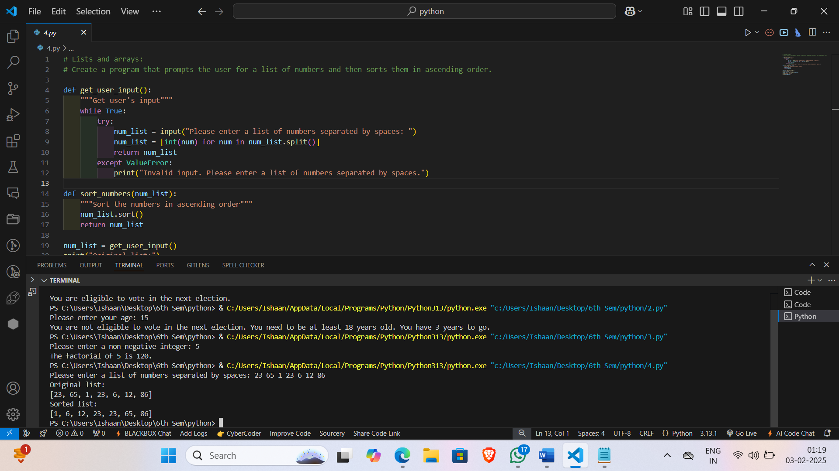

**Learning Outcomes:**

**Experiment 5**

**Aim:**

**Strings and string manipulation: Create a program that prompts the user for a string and then prints out the string reversed.**

**Code:**

# prompt the user to input a string and then print out the reversed string.

def reverse_string(input_str):

    return input_str[::-1]

# Prompt the user for a string

user_str = input("Please enter a string: ")

# Reverse the string

reversed_str = reverse_string(user_str)

# Print the reversed string

print("Reversed string:", reversed_str)

**Output:**

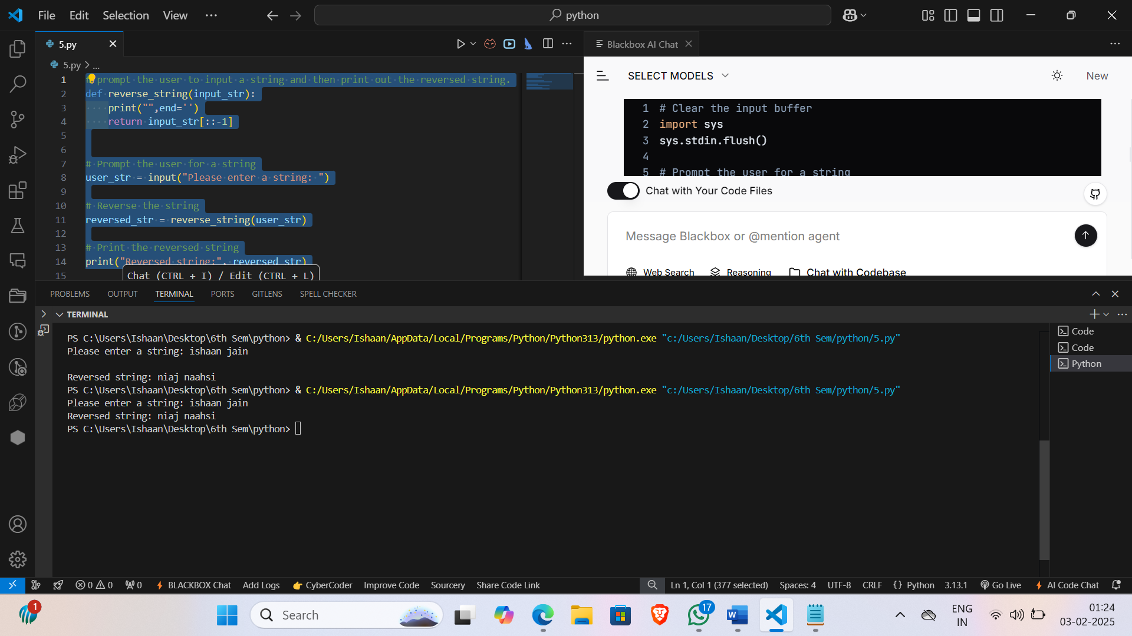

**Learning Outcomes:**

**Experiment 6**

**Aim: Functions: Create a program that defines a function to calculate the area of a circle based on the radius entered by the user.**

**Code:**

# Functions: Calculate the area of a circle based on the radius entered by the user.

def calculate_area(radius):

    area = 3.14159 * (radius ** 2)

    return area

radius=int(input("Enter the radius: "))

area = calculate_area(radius)

print("The area of the circle with radius", radius, "is", area)

**Output:**

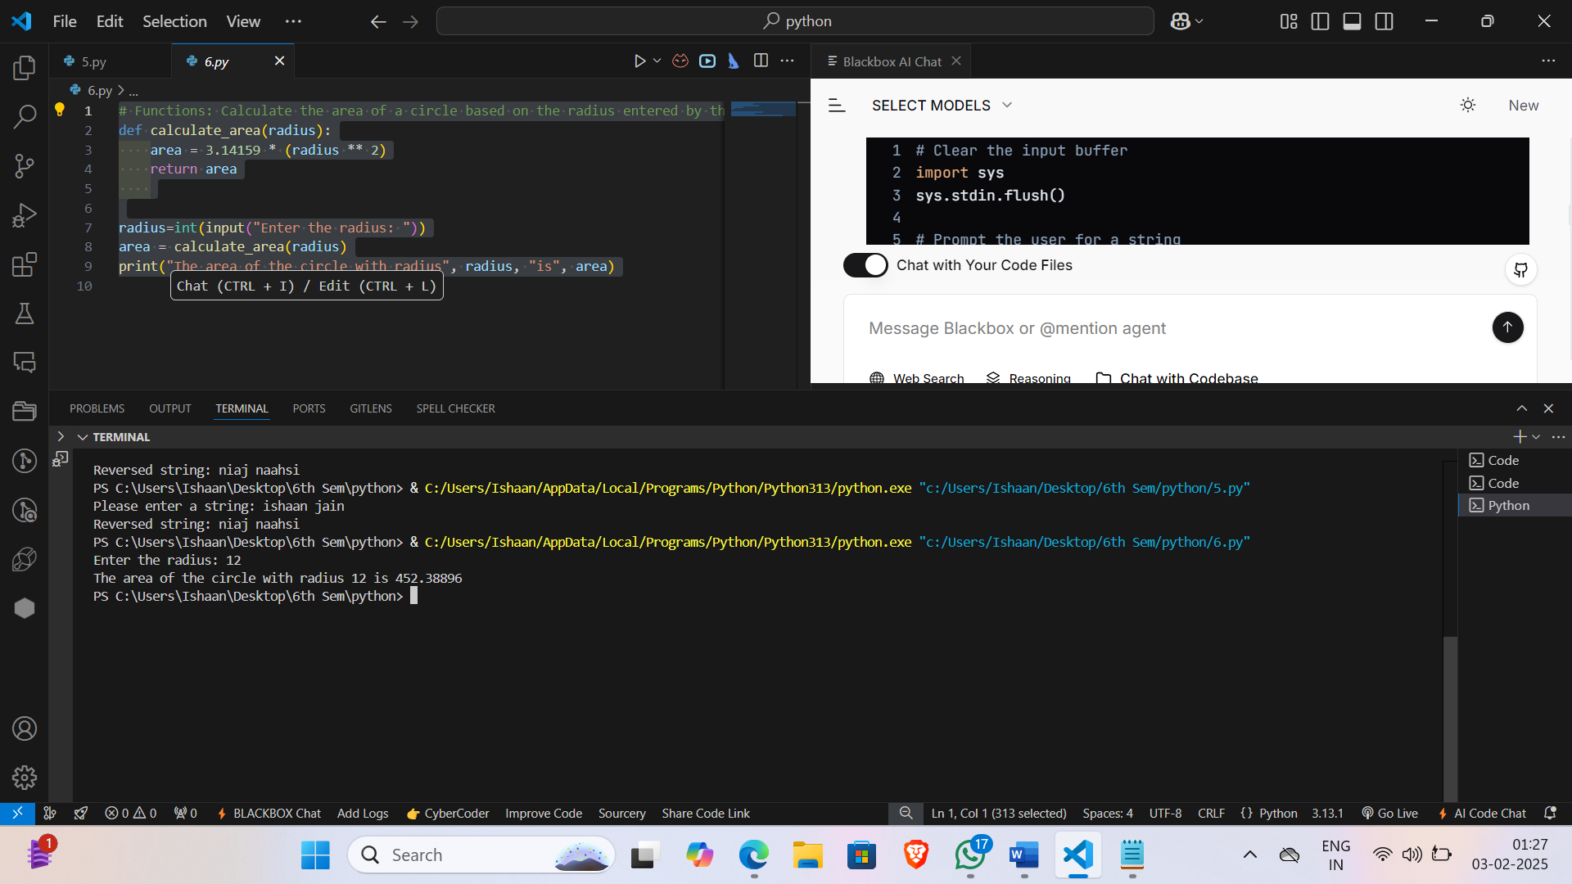

**Learning Outcomes:**

**Experiment 7**

**Aim:**

**Classes and objects: Create a program that defines a class to represent a car and then creates an object of that class with specific attributes.**

**Code:**

class Car:

    def __init__(self, make, model, year, color, mileage):

        self.make = make

        self.model = model

        self.year = year

        self.color = color

        self.mileage = mileage

    def honk(self):

        print("Honk honk!")

    def drive(self, miles):

        self.mileage += miles

        print(f"Drove {miles} miles. Current mileage: {self.mileage} miles")

    def display_details(self):

        print("Make:", self.make)

        print("Model:", self.model)

        print("Year:", self.year)

        print("Color:", self.color)

        print("Mileage:", self.mileage)

# Create a Car object

my_car = Car("Toyota", "Corolla", 2015, "Silver", 50000)

# Display the car's details

print("Car Details:")

my_car.display_details()

# # Simulate the car's horn honking

print("\nHonking the horn...")

my_car.honk()

# # Simulate driving the car

print("\nDriving the car...")

my_car.drive(100)

# # Display the car's updated details

print("\nUpdated Car Details:")

my_car.display_details()

**Output:**

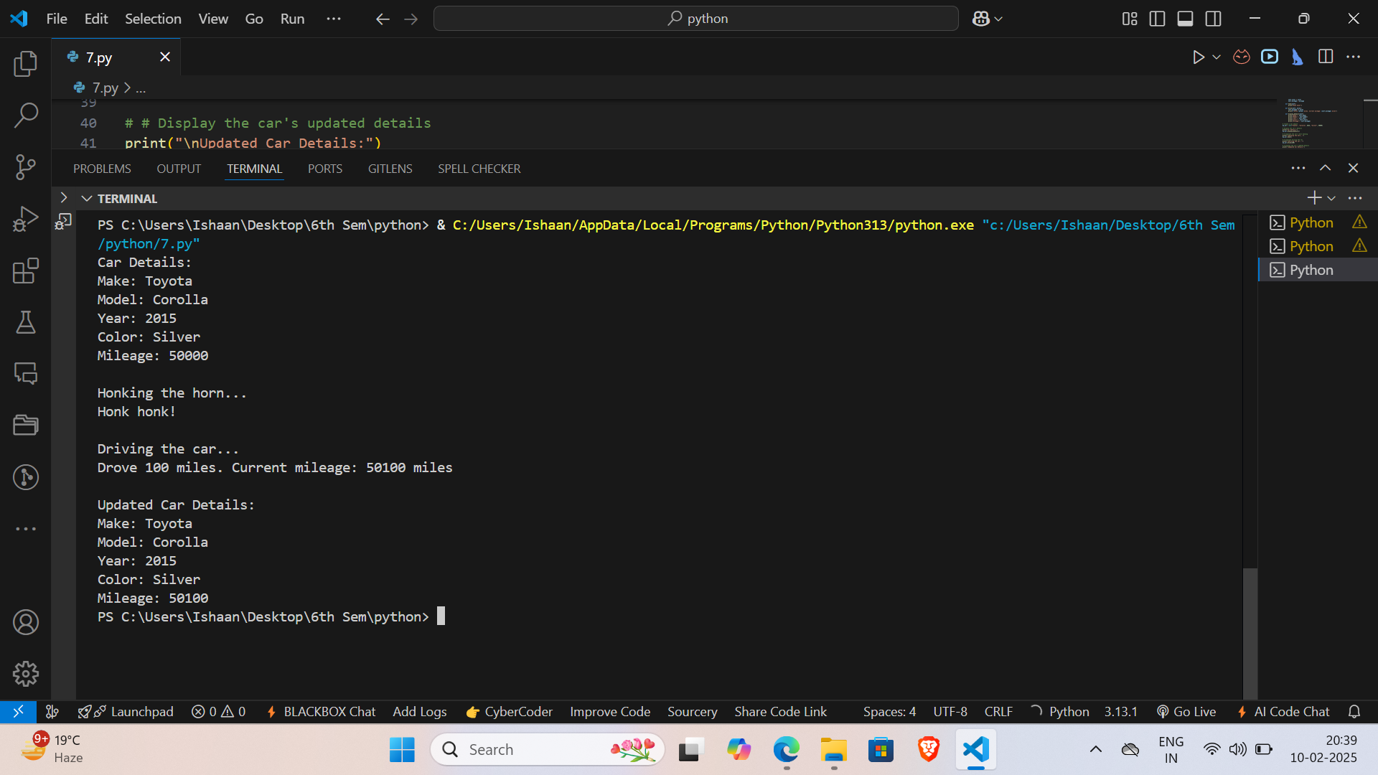

**Learning Outcomes:**

**Experiment 8**

**Aim:**

**File input/output: Create a program that reads data from a file and writes it to another file in a different format.**

**Code:**

import csv

import json

def csv_to_json(csv_file, json_file):

    data = []

    with open(csv_file, 'r') as csv_f:

        reader = csv.DictReader(csv_f)

        for row in reader:

            data.append(row)

    with open(json_file, 'w') as json_f:

        json.dump(data, json_f, indent=4)

 csv_file = '8.csv'

 json_file = '8.json'

 csv_to_json(csv_file, json_file)

 print(f"Data converted from {csv_file} to {json_file}")

**Output:**

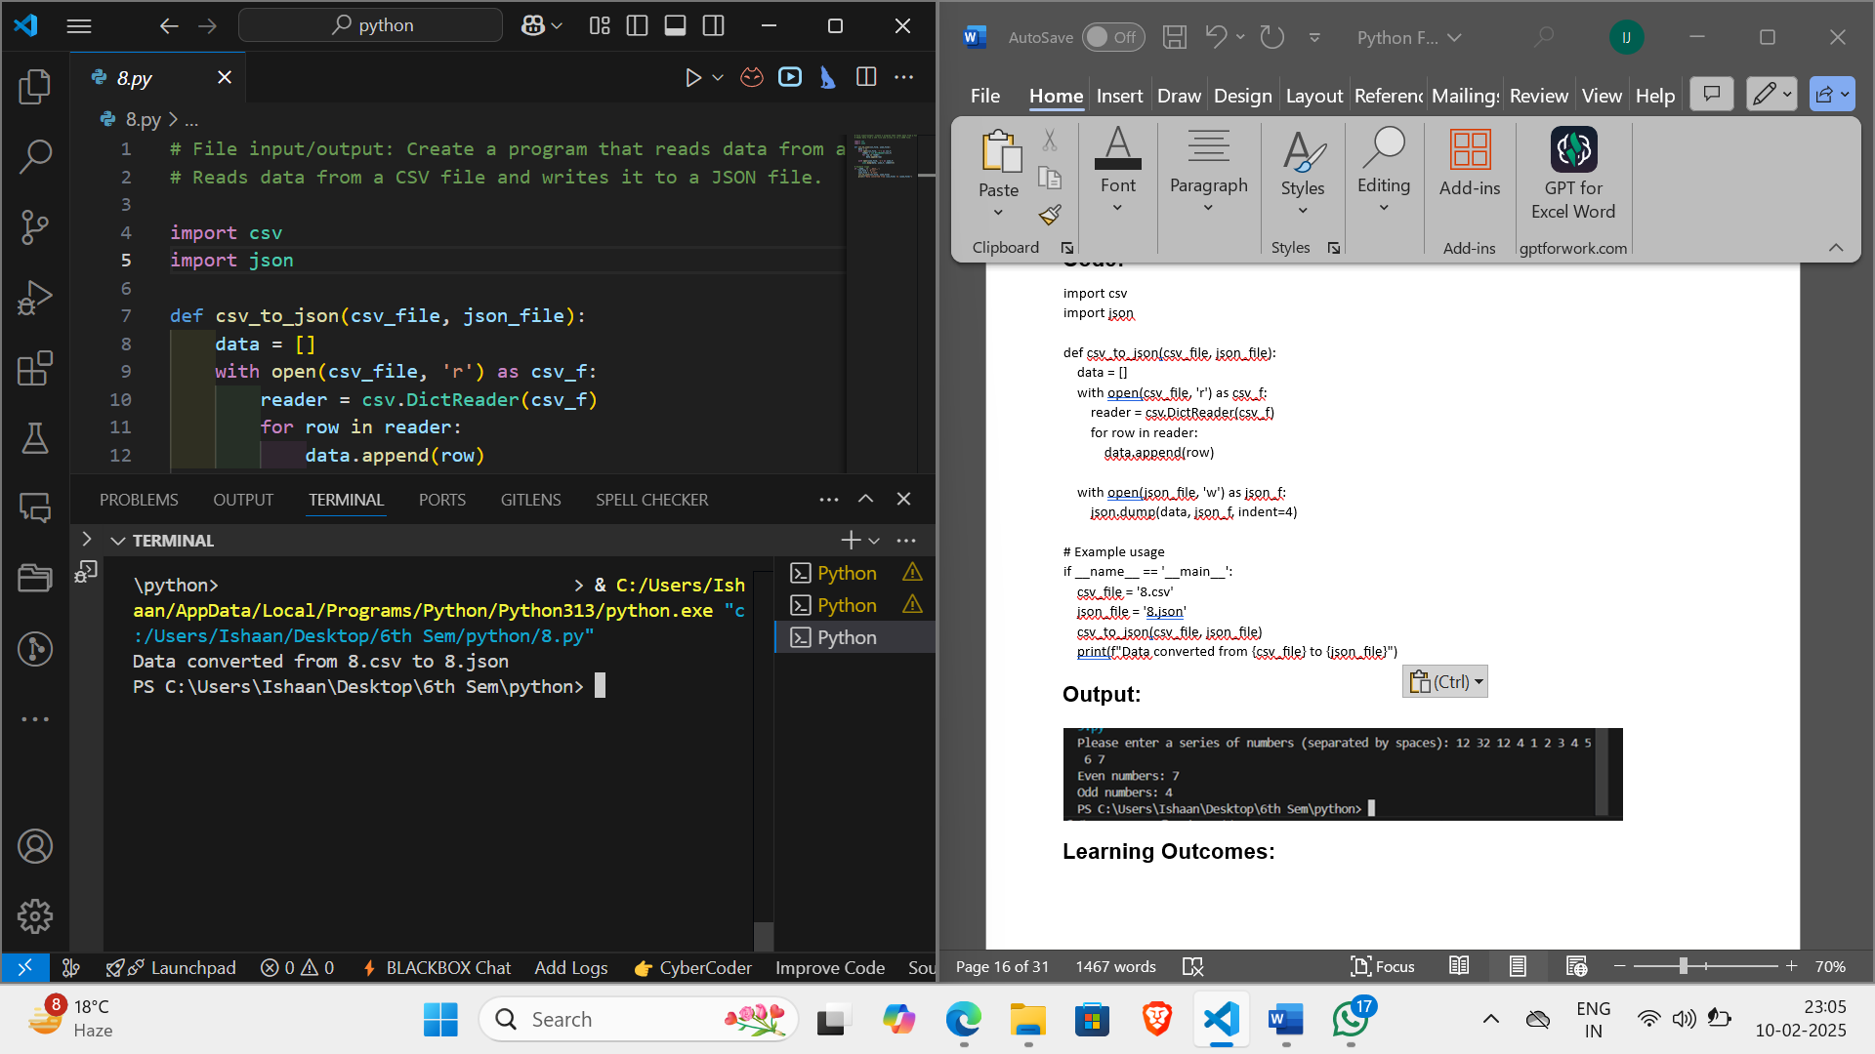

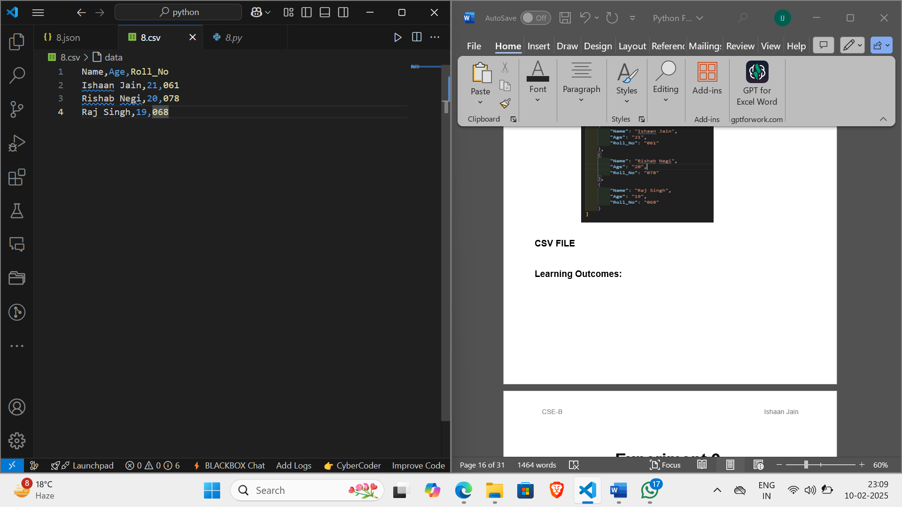**CSV FILE**

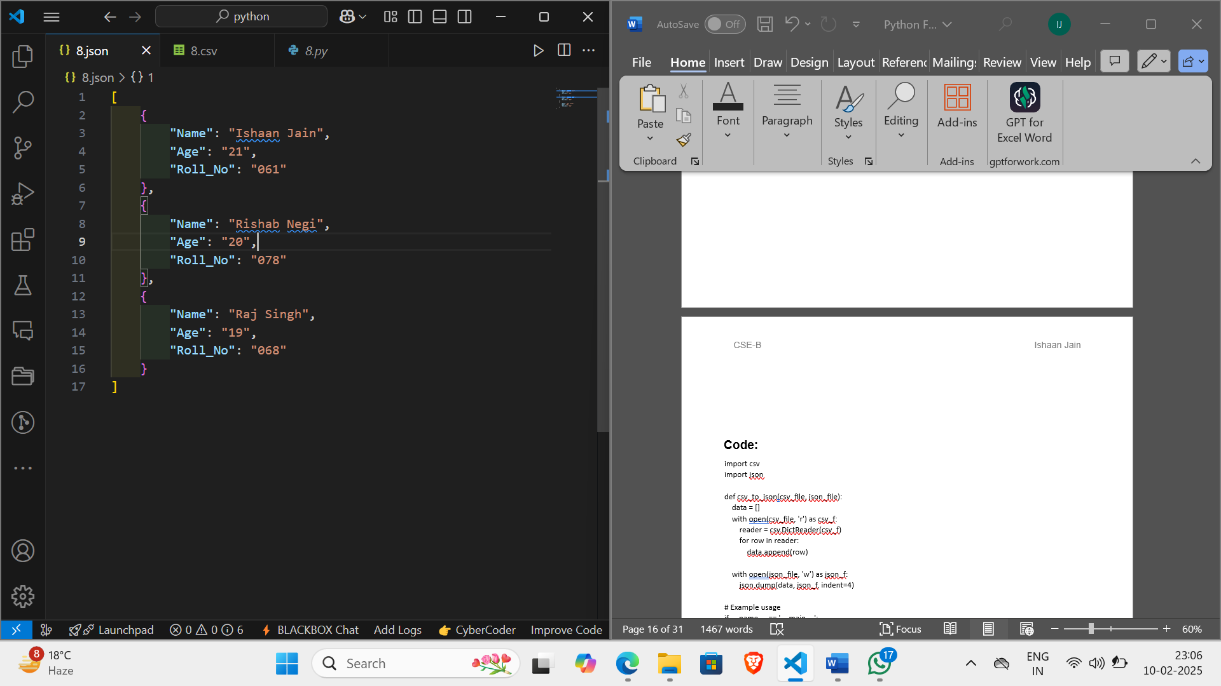**JSON FILE:**

**Learning Outcomes:**

**Experiment 9**

**Aim:**

**Regular expressions: Create a program that uses regular expressions to find all instances of a specific pattern in a text file.**

**Code:**

import re

def find_pattern(file_path, pattern):

    try:

        with open(file_path, 'r') as file:

            text = file.read()

            matches = re.findall(pattern, text)

            return matches

    except FileNotFoundError:

        print(f"File not found: {file_path}")

        return []

file_path = ("9.txt")

pattern = input("Enter the regular expression pattern to search for: ")

matches = find_pattern(file_path, pattern)

if matches:

    print(f"Found {len(matches)} instances of the pattern:")

    for i, match in enumerate(matches):

        print(f"{i+1}. {match}")

else:

    print("No instances of the pattern found.")

**OUTPUT:**

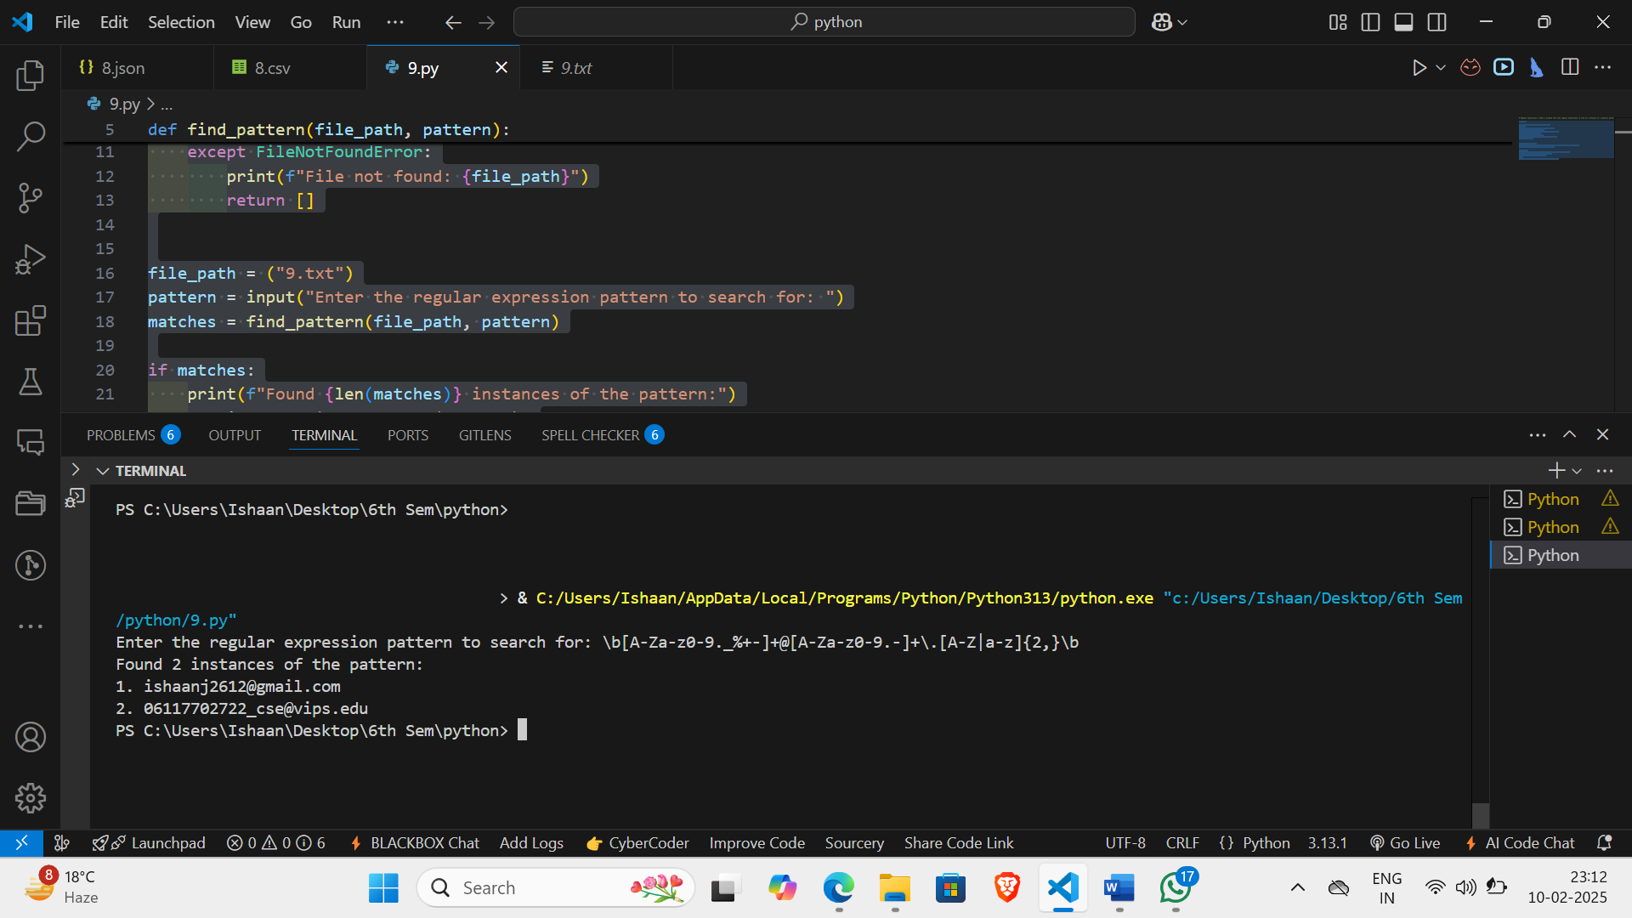

**TEXT FILE:**

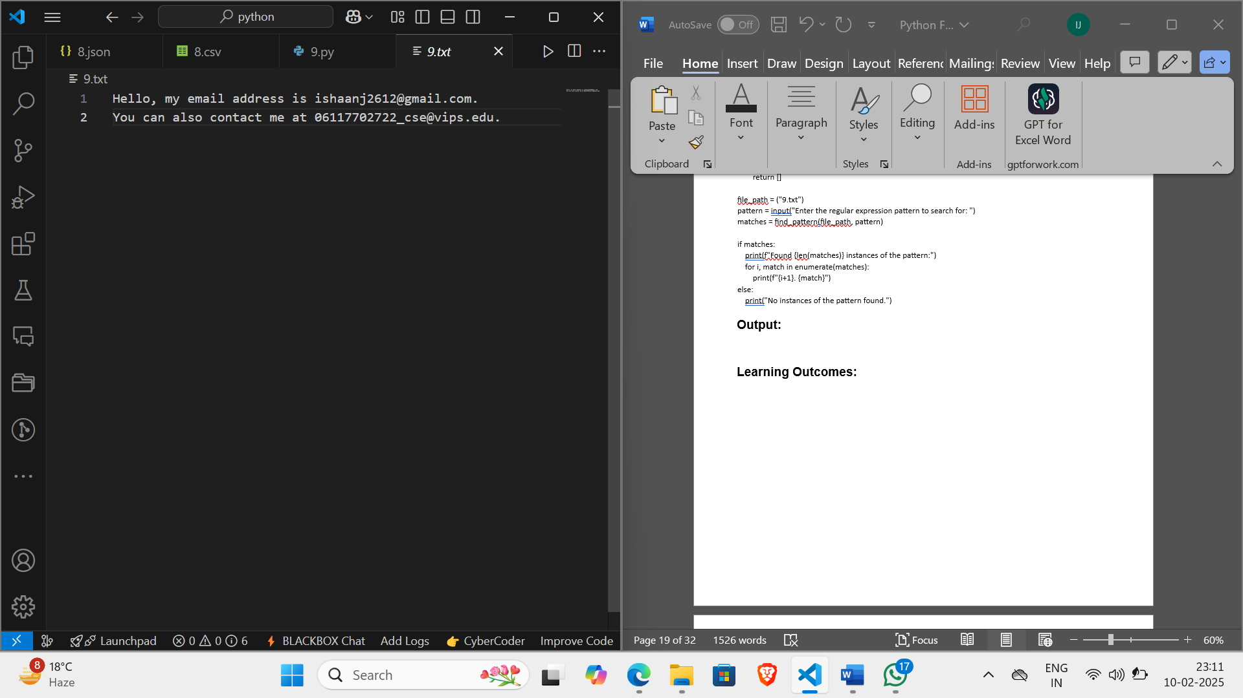

**Learning Outcomes:**

**Experiment 10**

**Aim:**

**Exception handling: Create a program that prompts the user for two numbers and then divides them, handling any exceptions that may arise.**

**Code:**

# Exception handling: Create a program that prompts the user for two numbers and then divides them,

# handling any exceptions that may arise.

def get_number(prompt):

    while True:

        try:

            return float(input(prompt))

        except ValueError:

            print("Invalid input. Please enter a number.")

def divide_numbers(num1, num2):

    try:

        return num1 / num2

    except ZeroDivisionError:

        print("Error: Cannot divide by zero.")

        return None

print("Enter two numbers for division")

num1 = get_number("Enter the first number: ")

num2 = get_number("Enter the second number: ")

result = divide_numbers(num1, num2)

if result is not None:

    print(f"{num1} / {num2} = {result:.2f}")

**Output:**

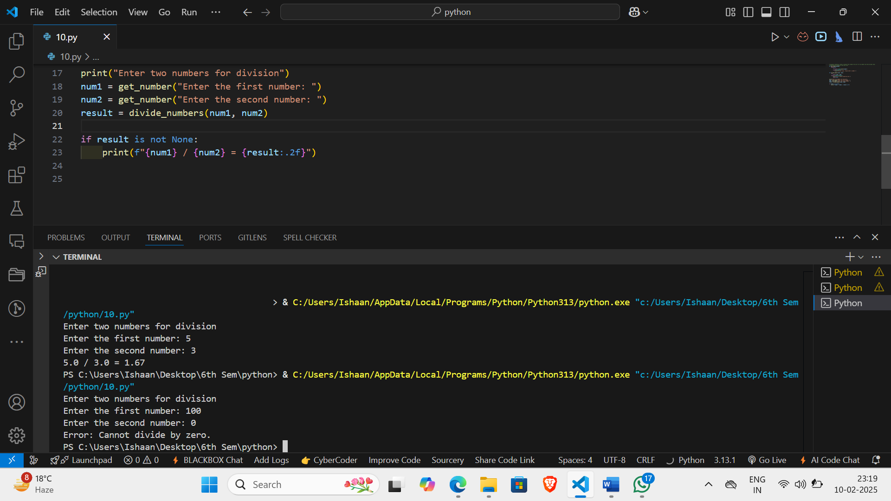

**Learning Outcomes:**

**Experiment 11**

**Aim:**

**GUI programming: Create a program that uses a graphical user interface (GUI) to allow the user to perform simple calculations.**

**Code:**

import tkinter as tk

from tkinter import messagebox

class Calculator:

    def __init__(self, root):

        self.root = root

        self.root.title("Simple Calculator")

        self.entry = tk.Entry(root, width=35, borderwidth=5)

        self.entry.grid(row=0, column=0, columnspan=4)

        self.create_buttons()

    def create_buttons(self):

        buttons = [

            '7', '8', '9', '/',

            '4', '5', '6', '*',

            '1', '2', '3', '-',

            '0', '.', '=', '+'

        ]

        row_val = 1

        col_val = 0

        for button in buttons:

            tk.Button(self.root, text=button, width=5, command=lambda button=button: self.click_button(button)).grid(row=row_val, column=col_val)

            col_val += 1

            if col_val > 3:

                col_val = 0

                row_val += 1

        tk.Button(self.root, text="Clear", width=22, command=self.clear_entry).grid(row=row_val, column=0, columnspan=4)

    def click_button(self, button):

        if button == '=':

            try:

                result = eval(self.entry.get())

                self.entry.delete(0, tk.END)

                self.entry.insert(tk.END, str(result))

            except Exception as e:

                messagebox.showerror("Error", str(e))

        else:

            self.entry.insert(tk.END, button)

    def clear_entry(self):

        self.entry.delete(0, tk.END)

root = tk.Tk()

calc = Calculator(root)

root.mainloop()

**Output:**

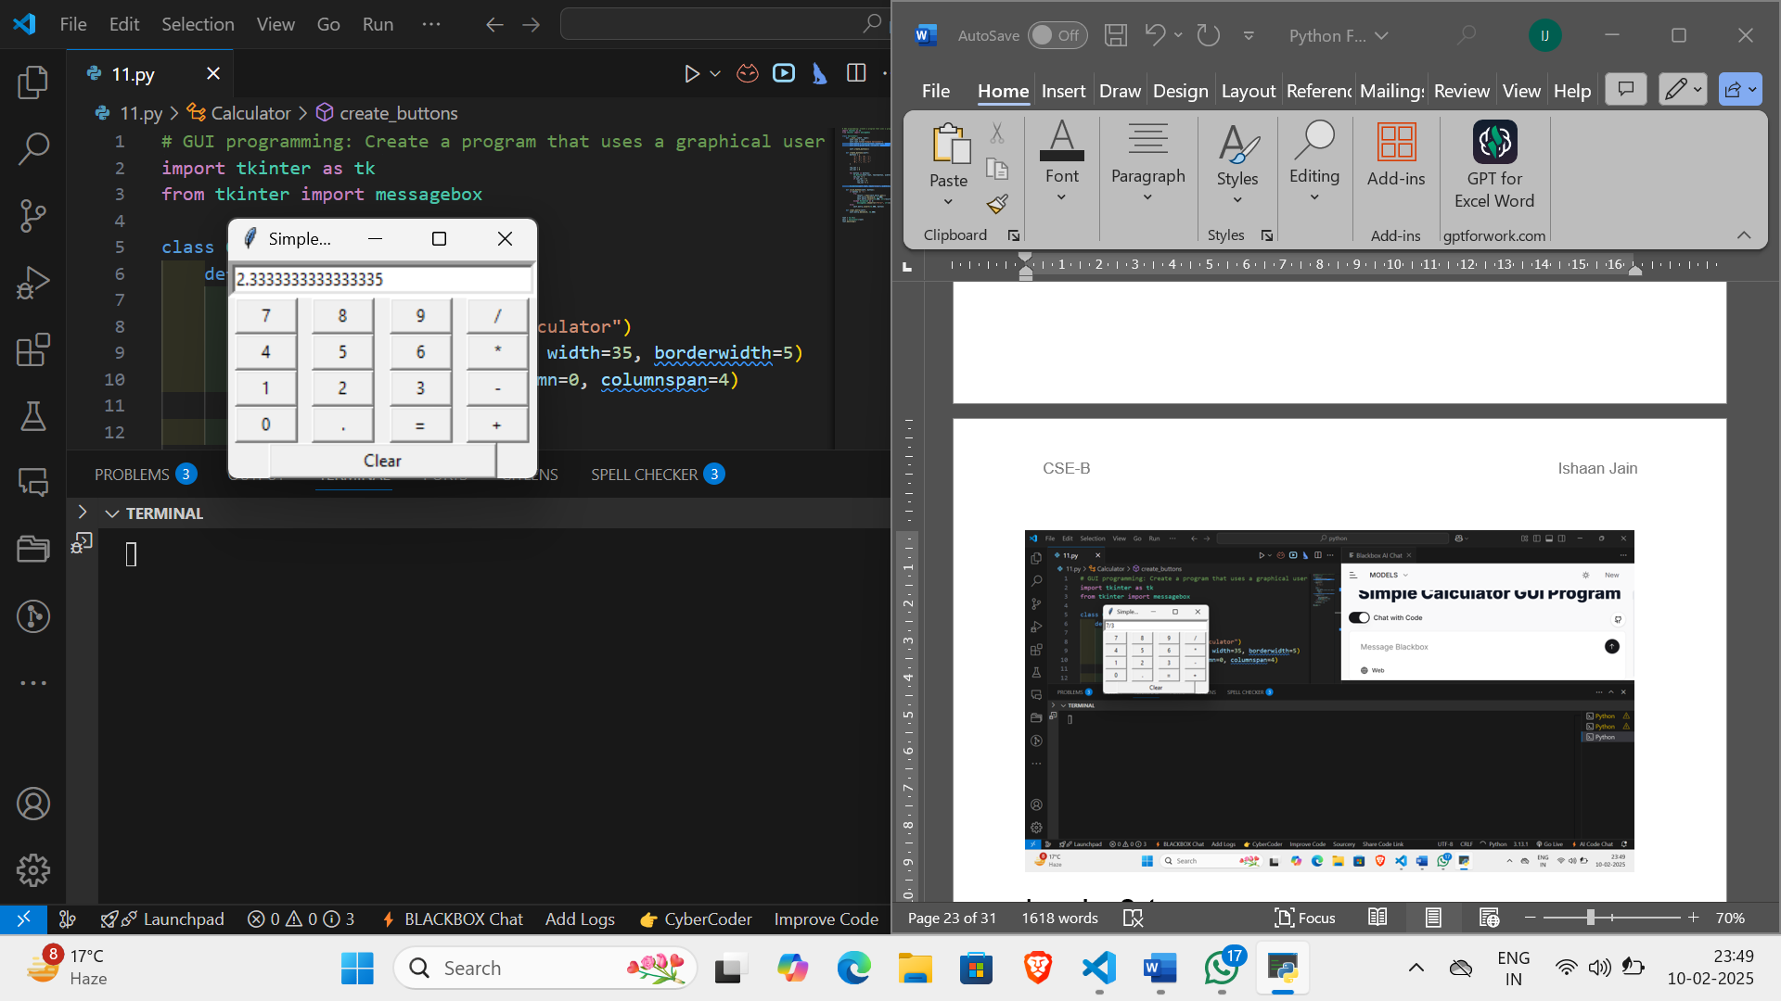

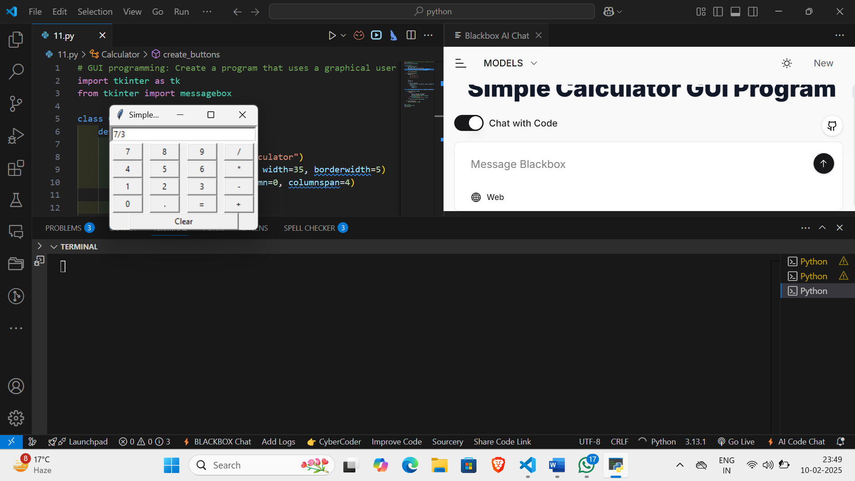

**Learning Outcomes:**

**Experiment 12**

**Aim:**

**Web scraping: Create a program that uses a web scraping library to extract data from a website and then stores it in a database.**

**Code:**

from bs4 import BeautifulSoup

import requests

url = 'https://en.wikipedia.org/wiki/List_of_largest_companies_in_the_United_States_by_revenue'

page = requests.get(url)

soup = BeautifulSoup(page.text, 'html')

soup.find('table')

soup.find_all('table')[1]

soup.find('table', class_ = 'wikitable sortable')

table = soup.find_all('table')[1]

world_titles = table.find_all('th')

world_titles

world_table_titles = [title.text.strip() for title in world_titles]

print(world_table_titles)

import pandas as pd

df = pd.DataFrame(columns = world_table_titles)

column_data = table.find_all('tr')

for row in column_data[1:]:

    row_data = row.find_all('td')

    individual_row_data = [data.text.strip() for data in row_data]

    length = len(df)

    df.loc[length] = individual_row_data

df.to_csv(r'C:\Users\Ishaan\Desktop\6th Sem\python\12\12.csv', index = False)

**OUTPUT:**

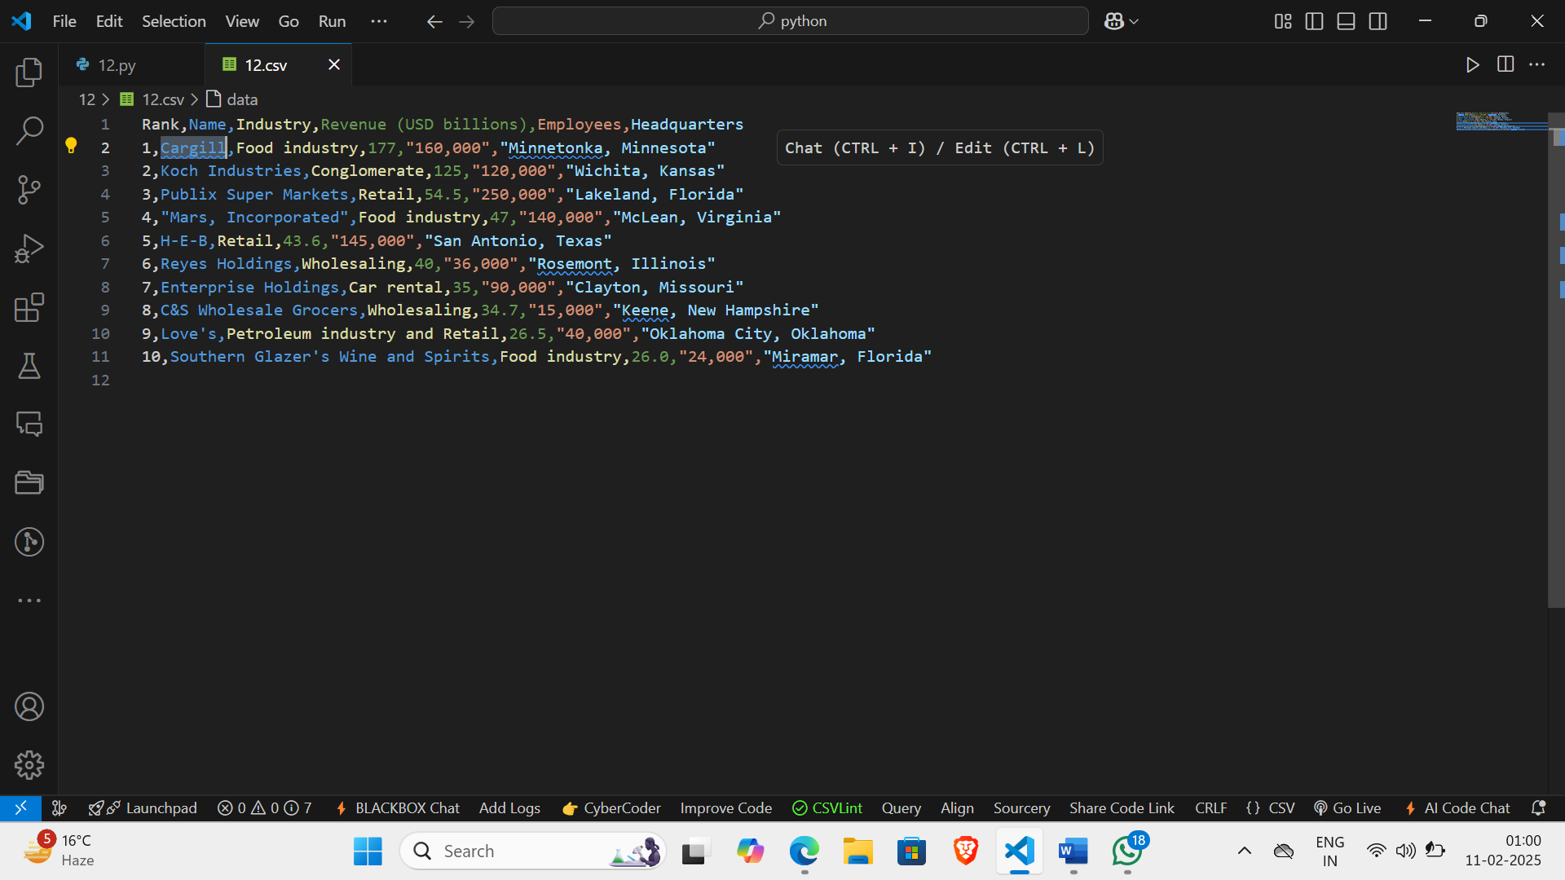

**WEBPAGE:**

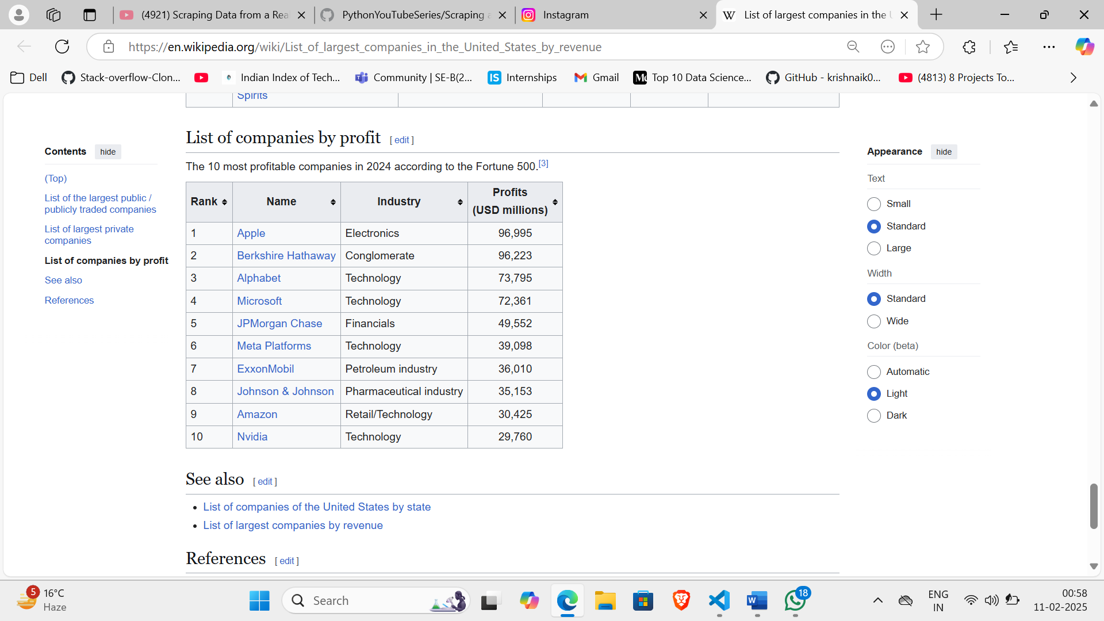

**Learning Outcomes:**

**Experiment 13**

**Aim:**

**Data visualization: Create a program that reads data from a file and then creates a visualization of that data using a data visualization library.**

**Code:**

import matplotlib.pyplot as plt

import numpy as np

import pandas as pd

def read_data_from_file(filename):

    try:

        data = pd.read_csv(filename)

        return data

    except Exception as e:

        print(f"Error reading file: {e}")

        return None

def create_visualization(data):

    if data is None:

        return

    # Get the column names

    columns = data.columns

    # Create a figure and axis

    fig, ax = plt.subplots(2, 2, figsize=(12, 8))

    # Plot the data

    ax[0, 0].plot(data[columns[0]], data[columns[1]])

    ax[0, 0].set_title('Line Plot')

    ax[0, 0].set_xlabel(columns[0])

    ax[0, 0].set_ylabel(columns[1])

    ax[0, 1].bar(data[columns[0]], data[columns[1]])

    ax[0, 1].set_title('Bar Chart')

    ax[0, 1].set_xlabel(columns[0])

    ax[0, 1].set_ylabel(columns[1])

    ax[1, 0].scatter(data[columns[0]], data[columns[1]])

    ax[1, 0].set_title('Scatter Plot')

    ax[1, 0].set_xlabel(columns[0])

    ax[1, 0].set_ylabel(columns[1])

    ax[1, 1].hist(data[columns[1]], bins=10)

    ax[1, 1].set_title('Histogram')

    ax[1, 1].set_xlabel(columns[1])

    ax[1, 1].set_ylabel('Frequency')

    # Layout so plots do not overlap

    fig.tight_layout()

    plt.show()

filename = '13/data.txt'  # Replace with your file name

data = read_data_from_file(filename)

create_visualization(data)

**Output:**

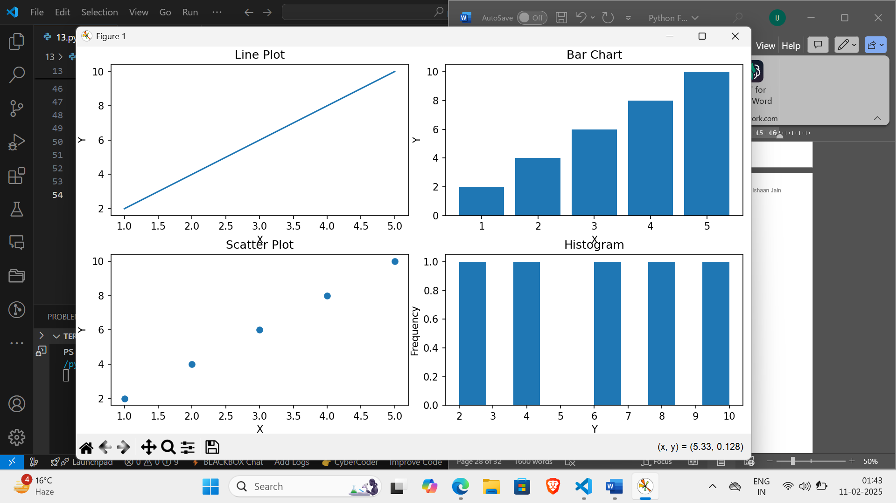

**Learning Outcomes:**

**Experiment 14**

**Aim:**

**Machine learning: Create a program that uses a machine learning library to classify images based on their content.**

**Code:**

**MACHINE LEARNING CODE**

import numpy as np

import pandas as pd

import matplotlib.pyplot as plt

import tensorflow as tf

from tensorflow import keras

from tensorflow.keras import layers

data_train_path = 'Fruits_Vegetables/train'

data_test_path = 'Fruits_Vegetables/test'

data_val_path = 'Fruits_Vegetables/validation'

img_width = 180

img_height =180

data_train = tf.keras.utils.image_dataset_from_directory(

    data_train_path,

    shuffle=True,

    image_size=(img_width, img_height),

    batch_size=32,

    validation_split=False)

data_cat = data_train.class_names

data_val = tf.keras.utils.image_dataset_from_directory(data_val_path,

                                                       image_size=(img_height,img_width),

                                                       batch_size=32,

                                                        shuffle=False,

                                                       validation_split=False)

data_test = tf.keras.utils.image_dataset_from_directory(

data_test_path,

    image_size=(img_height,img_width),

    shuffle=False,

    batch_size=32,

    validation_split=False

)

plt.figure(figsize=(10,10))

for image, labels in data_train.take(1):

    for i in range(9):

        plt.subplot(3,3,i+1)

        plt.imshow(image[i].numpy().astype('uint8'))

        plt.title(data_cat[labels[i]])

        plt.axis('off')

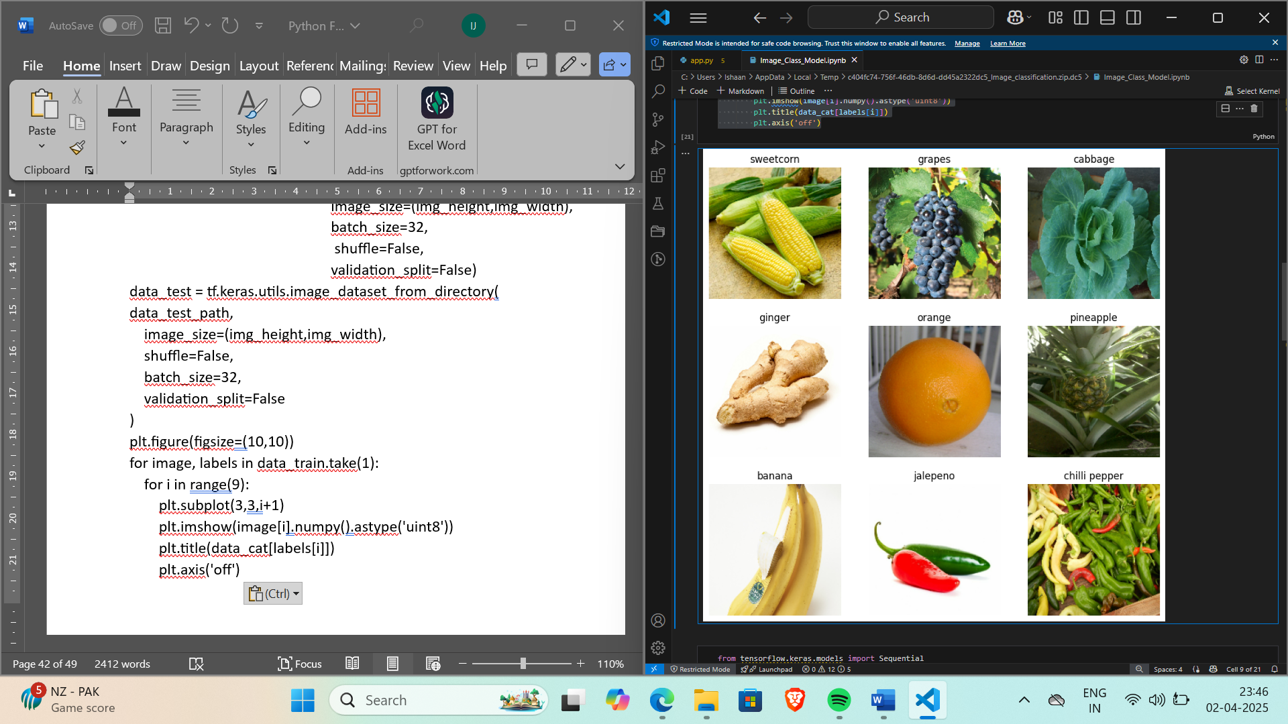

from tensorflow.keras.models import Sequential

model = Sequential([

    layers.Rescaling(1./255),

    layers.Conv2D(16, 3, padding='same', activation='relu'),

    layers.MaxPooling2D(),

    layers.Conv2D(32,3, padding='same',activation='relu'),

    layers.MaxPooling2D(),

    layers.Conv2D(64, 3, padding='same', activation='relu'),

    layers.MaxPooling2D(),

    layers.Flatten(),

    layers.Dropout(0.2),

    layers.Dense(128),

    layers.Dense(len(data_cat))

])

model.compile(optimizer='adam', loss=tf.keras.losses.SparseCategoricalCrossentropy(from_logits=True), metrics=['accuracy'])

epochs_size = 25

history = model.fit(data_train, validation_data=data_val, epochs=epochs_size)

epochs_range = range(epochs_size)

plt.figure(figsize=(8,8))

plt.subplot(1,2,1)

plt.plot(epochs_range,history.history['accuracy'],label = 'Training Accuracy')

plt.plot(epochs_range, history.history['val_accuracy'],label = 'Validation Accuracy')

plt.title('Accuracy')

plt.subplot(1,2,2)

plt.plot(epochs_range,history.history['loss'],label = 'Training Loss')

plt.plot(epochs_range, history.history['val_loss'],label = 'Validation Loss')

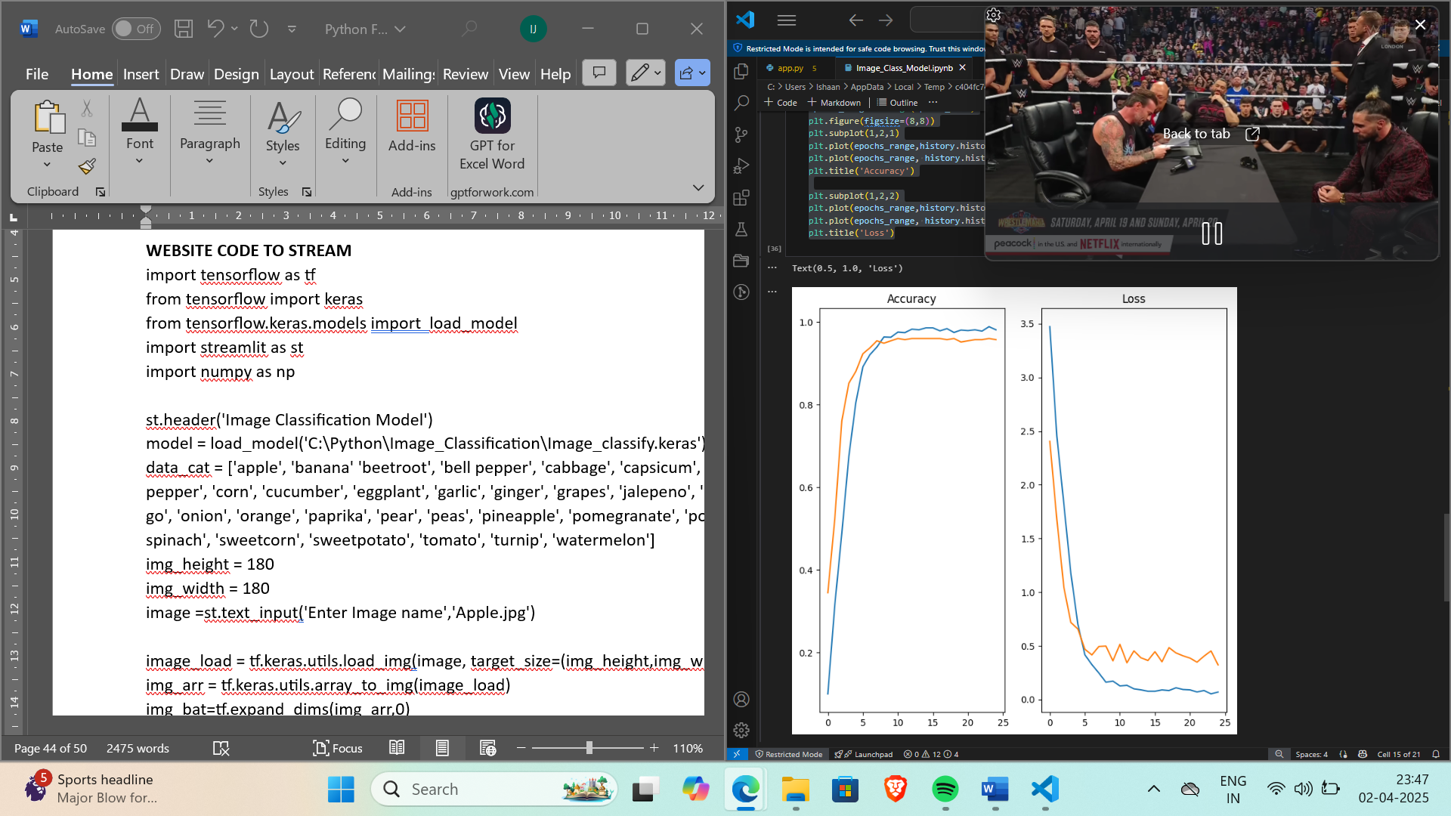plt.title('Loss')

image = 'corn.jpg'

image = tf.keras.utils.load_img(image, target_size=(img_height,img_width))

img_arr = tf.keras.utils.array_to_img(image)

img_bat=tf.expand_dims(img_arr,0)

predict = model.predict(img_bat)

score = tf.nn.softmax(predict)

print('Veg/Fruit in image is {} with accuracy of {:0.2f}'.format(data_cat[np.argmax(score)],np.max(score)*100))

OUTPUT:Veg/Fruit in image is sweetcorn with accuracy of 78.90

model.save('Image_classify.keras')

**WEBSITE CODE TO STREAM**

import tensorflow as tf

from tensorflow import keras

from tensorflow.keras.models import  load_model

import streamlit as st

import numpy as np

st.header('Image Classification Model')

model = load_model('C:\Python\Image_Classification\Image_classify.keras')

data_cat = ['apple', 'banana' 'beetroot', 'bell pepper', 'cabbage', 'capsicum', 'carrot', 'cauliflower', 'chilli pepper', 'corn', 'cucumber', 'eggplant', 'garlic', 'ginger', 'grapes', 'jalepeno', 'kiwi', 'lemon', 'lettuce', 'mango', 'onion', 'orange', 'paprika', 'pear', 'peas', 'pineapple', 'pomegranate', 'potato', 'raddish', 'soyabeans', 'spinach', 'sweetcorn', 'sweetpotato', 'tomato', 'turnip', 'watermelon']

img_height = 180

img_width = 180

image =st.text_input('Enter Image name','Apple.jpg')

image_load = tf.keras.utils.load_img(image, target_size=(img_height,img_width))

img_arr = tf.keras.utils.array_to_img(image_load)

img_bat=tf.expand_dims(img_arr,0)

predict = model.predict(img_bat)

score = tf.nn.softmax(predict)

st.image(image, width=200)

st.write('Veg/Fruit in image is ' + data_cat[np.argmax(score)])

st.write('With accuracy of ' + str(np.max(score)*100))

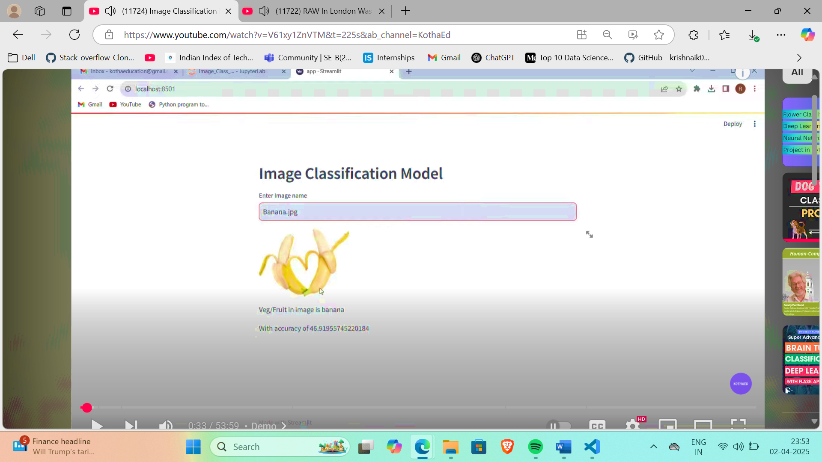**Output:**

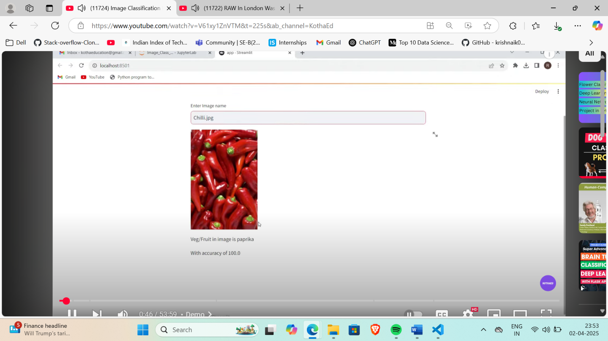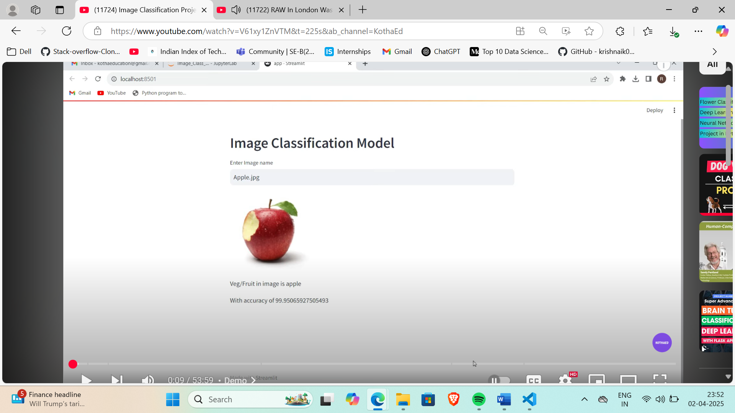

**Learning Outcomes:**

**Experiment 15**

**Aim:**

**Networking: Create a program that uses a networking library to communicate with a server and retrieve data**

**from it.**

**Code:**

**CLIENT-SIDE CODE**

import requests

class NetworkingClient:

    def __init__(self, url):

        self.url = url

    def get_data(self):

        try:

            response = requests.get(self.url)

            response.raise_for_status()  # Raise an exception for bad status codes

            return response.text

        except requests.exceptions.RequestException as e:

            print(f"Error: {e}")

            return None

url = "http://localhost:8000/"

client = NetworkingClient(url)

data = client.get_data()

if data:

    print("Received data:")

    print(data)

else:

    print("Error in fetching the data")

**SERVER-SIDE CODE**

from http.server import BaseHTTPRequestHandler, HTTPServer

class RequestHandler(BaseHTTPRequestHandler):

    def do_GET(self):

        self.send_response(200)

        self.send_header('Content-type', 'text/html')

        self.end_headers()

        text = """

        <h1>Welcome to our server!</h1>

        <p>This is a simple HTTP server written in Python using the http.server module.</p>

        <p>The server is running on localhost:8000 and can be accessed from any device on the same network.</p>

        <p>Some possible uses for this server include:</p>

        <ul>

            <li>Serving static websites or web applications</li>

            <li>Providing a RESTful API for other applications to interact with</li>

            <li>Hosting a blog or news site</li>

            <li>Creating a simple file sharing system</li>

        </ul>        """

        self.wfile.write(text.encode())

def run_server():

    server_address = ('localhost', 8000)

    httpd = HTTPServer(server_address, RequestHandler)

    print("Server running on localhost:8000")

    httpd.serve_forever()

run_server()

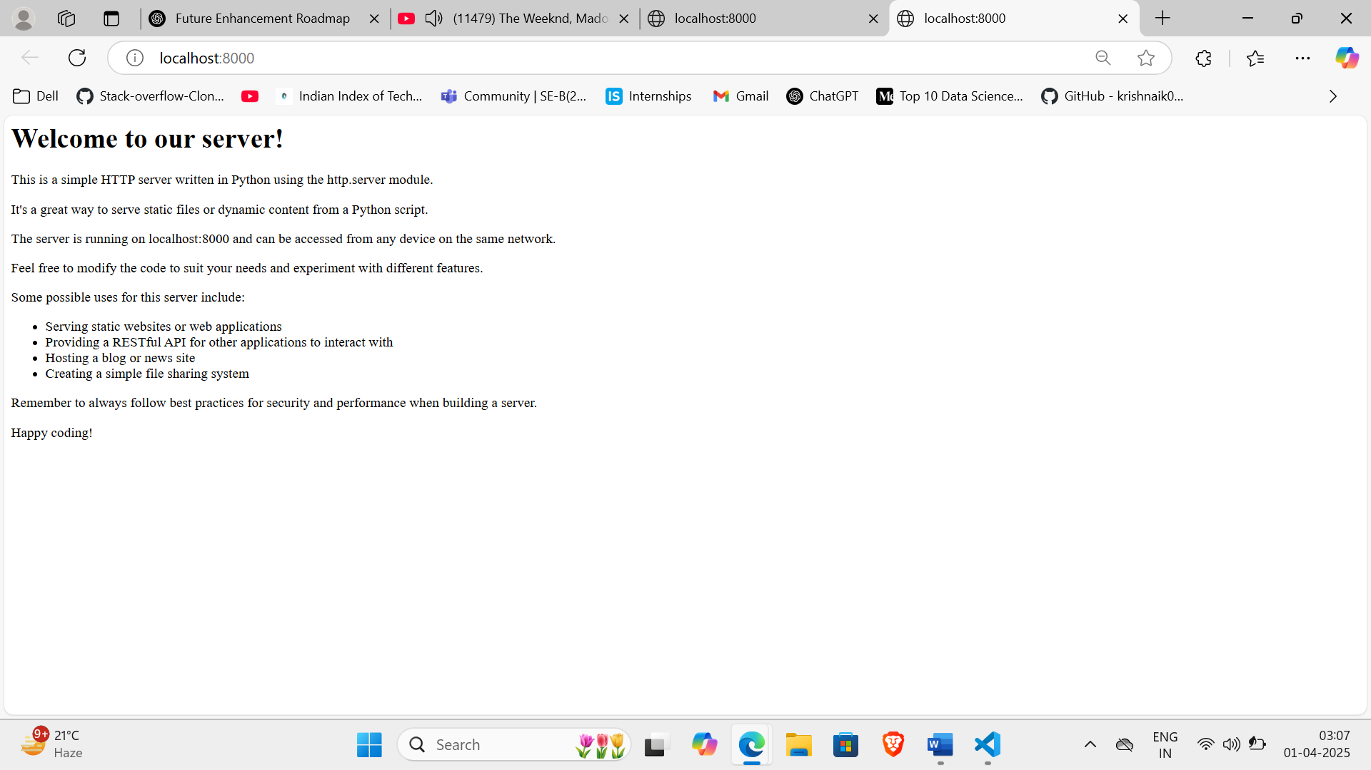**Output:**

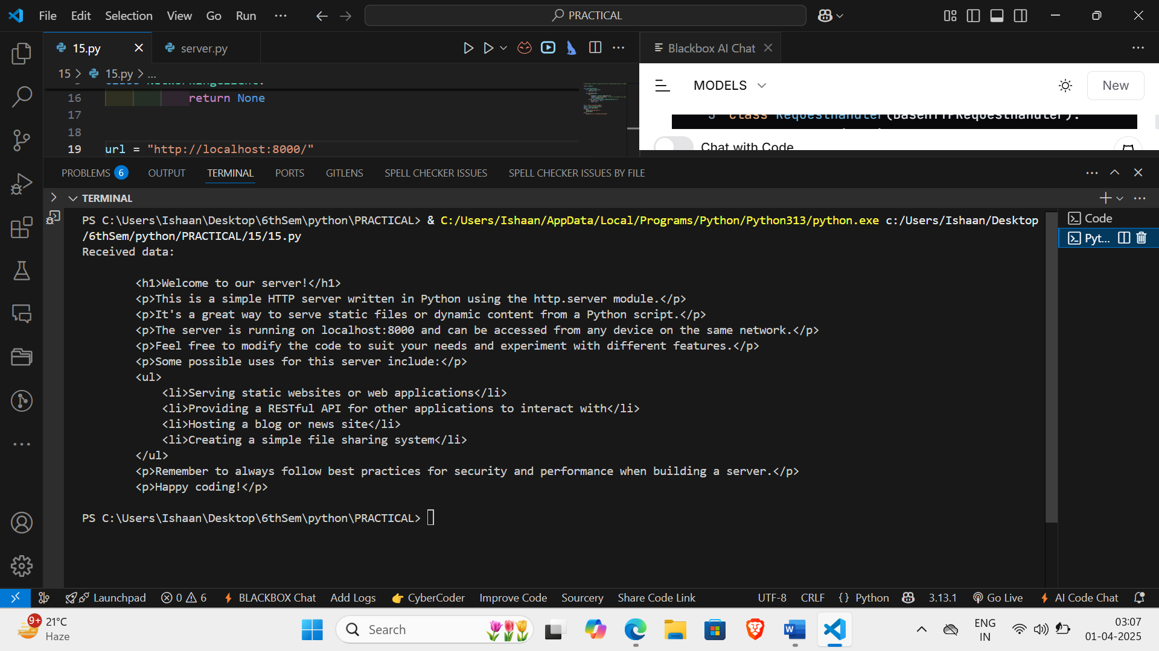

**Learning Outcomes:**